by
Tiffany R. Johnson
EKU Writing Project
Summer 2013 / Fall 2013
Pedagogically Recycled

Importance of Analysis
In my social studies class this year, I have tried to focus on using photographs and other visuals as prompts for writing and analysis. Angie Burton presented an activity during the SI that prompted us to write about primary sources. I have begun to look for primary sources and interesting pictures related to our social studies topics to promote writing for learning and writing to demonstrate learning. This has worked well, especially with my students, as many have reading levels that are below grade level. One of my favorite ways to use these materials, both pictures and primary sources, are as bellringers to assess whether or not students understood and have retained information from previous lessons. It has become a simple way for me to learn which of my students are getting a grasp on the concepts presented.
Example…
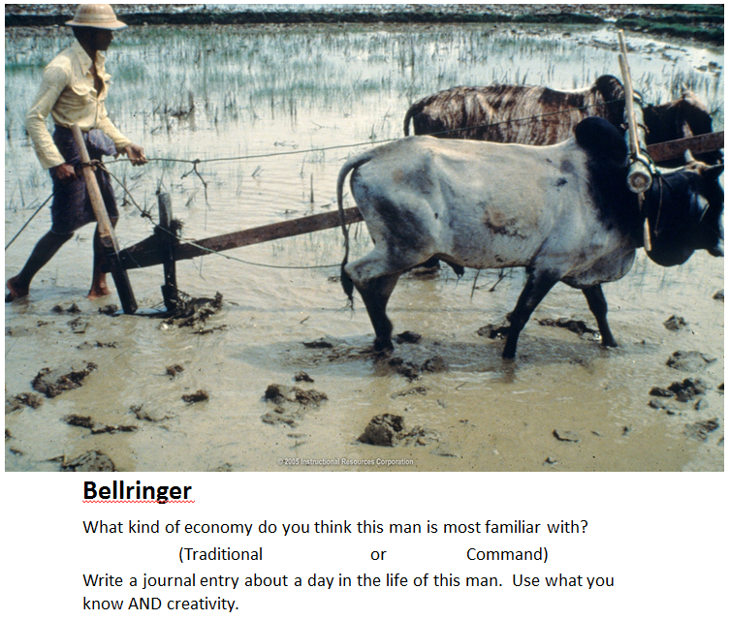

Experiential Writing
Erin’s presentation on experiential writing gave me an idea at the beginning of the year. Students are expected to learn how to write a lab report, which includes hypotheses, observations and conclusions. I also had to teach the scientific method. I combined teaching the scientific method with writing lab reports through a hands-on experience that got them involved in learning kinesthetically. We created a lab report based upon an experiment we conducted using the scientific method. This activity worked very well because students were writing about something they had just experienced, which was much easier than writing about something they read or saw. This made the lab report writing and scientific method come alive for my kids.
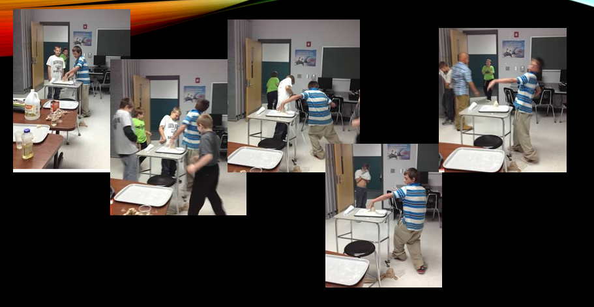

Using the Environment
Vivien Bowles’ presentation made my science class come alive. We began the year talking about Inquiry and Investigation. During this time, I decided to take advantage of the beautiful weather and location of our school and take my kids outside to make inquiries about their natural surroundings. We took our writing notebooks outside and wrote down observations of things we saw and questions about things we didn’t understand. The beauty of this activity was seeing pages fill up with students’ unspoken curiosity. Not only did these types of activities give us a reason to write, it led us deeper into critical thinking skills be requiring students to answer their own questions. We dug into research online and in the library to uncover the answers about things that surround us that we never really pay attention to. Students learned about different types of spiders, ants, and other animals. They researched their own questions and began to show pride in their work that I hadn’t seen before. In addition to answering our own questions, student excitement built up even more when they saw our pictures and investigations on the class website.
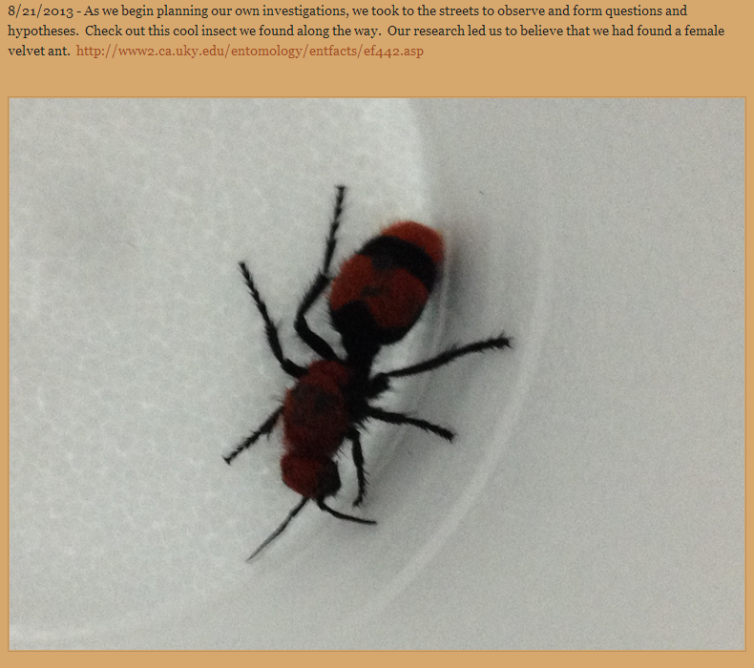
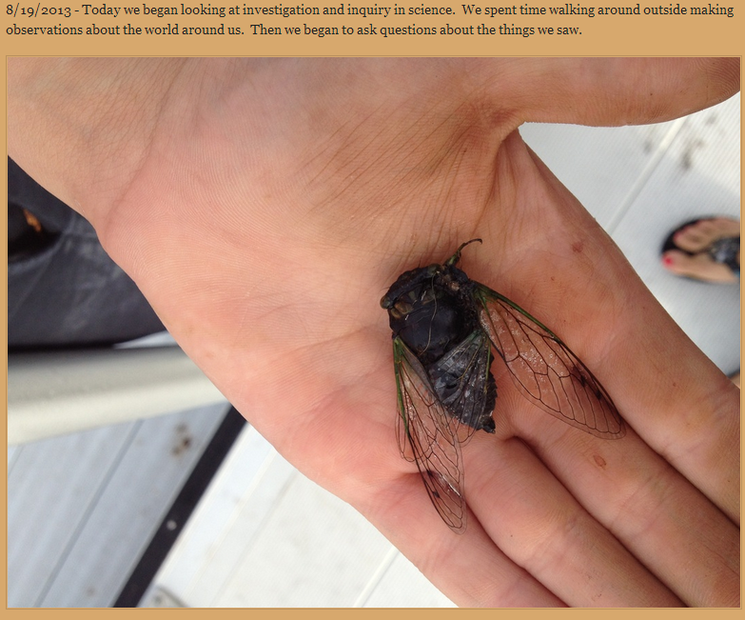

Glogs Away!
In social studies, the five themes of geography ran rampant when students demonstrated their understanding through Glogging. Instead of a traditional “test”, students had to apply the information they gained by creating and analyzing a Glog. Each student had to represent each of the five themes through the use of a picture or video. Afterwards, they wrote justifications of their visual selections. Through this activity, I was able to easily assess if they understood the concepts more thoroughly than I would have been able to assess understanding through a traditional test. Furthermore, I had more fun and the kids had a blast learning a new way to present information.

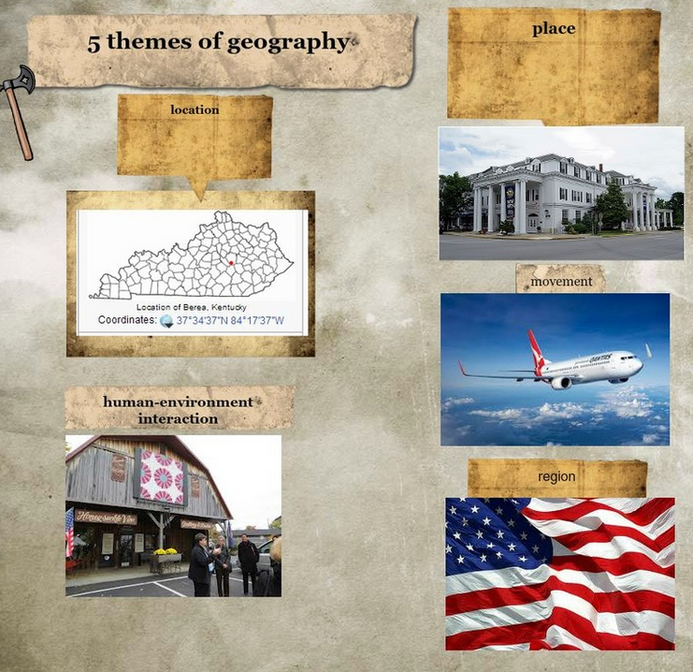

Blogging Beliefs
I incorporated Eddie and Jared’s presentations in one of the writing pieces we began for language arts. After using prewriting activities extensively to develop a personal belief statement, I realized that my students did not yet have the ability or skills to clearly identify and write about important personal beliefs. The prewriting portion gave me the ability to understand the struggles before I assigned a writing task that my students would have struggled with and many would not have experienced success. In that regard, the prewriting activities were absolutely a positive use of time. It saved a lot of difficulty by giving me the knowledge of where my students’ abilities lied in regards to this particular task. In the meantime, giving students the experience to blog about their beliefs as part of the prewriting activities gave them the opportunity to interact with other students they usually don’t spend time with and provided them with feedback from peers.
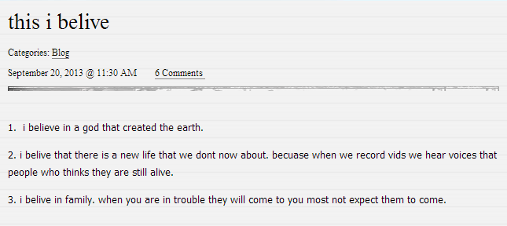
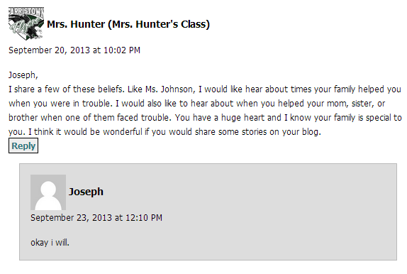

Connecting Illustrating…
Caitlyn presented an activity in which we used illustrations as a basis for writing and adding detail. I decided to take this idea and twist it a little because my students usually do not like drawing. In this activity, students found pictures online that they felt represented an important part of who they were. After locating the picture(s), students were tasked with writing a six-word memoir using the picture and the beliefs they held about themselves. This activity worked for us! The students truly enjoyed creating a piece of writing based on both their personal beliefs as they related to themselves and found pictures online.
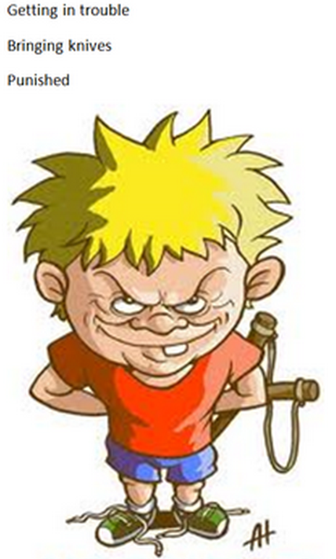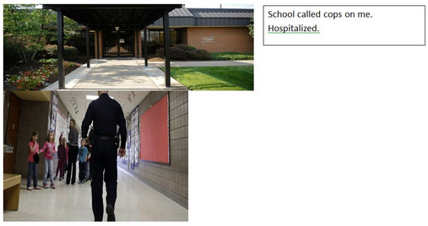
Another way I used illustrations in class was during a unit on memoirs. As students wrote their memoirs, I discovered that idea development was very difficult for many kids. One of the strategies I used was to create comic strip blocks and each student used those to illustrate the event they were writing about in sequence from beginning to end. They drew and colored these pictures and then went back to add in details to their memoirs. Every student in class was able to go back into their writing and add details that they previously did not include or did not remember. This proved to be a very successful activity for the students in my class.

The School-Wide Writing Marathon
My absolute favorite recycled activity from the SI was Farristown Middle School’s school-wide writing marathon. It was my pleasure to organize and implement a half-day school-wide writing marathon. Every student and adult in the school took part in the marathon. In my group, I was pleasantly surprised to discover the talent of some of my students when they were writing without being given a topic or expectation. This was definitely a successful recycled activity.
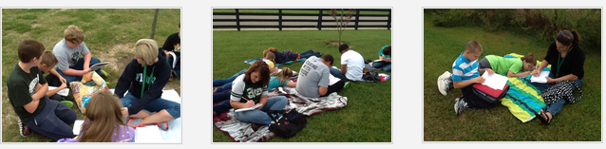

Odds and Ends

